TOPIC 2-BRUTE FORCE
1.
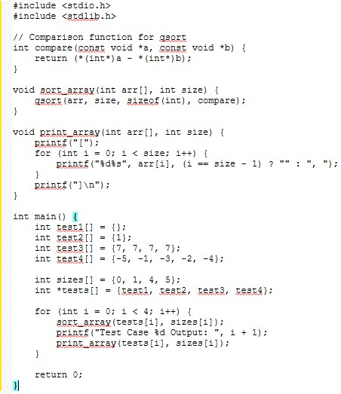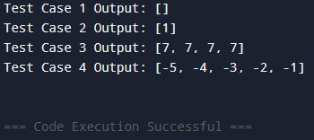
Time complexity: $O\left(N\log{N}\right)$
Space Complexity: $O\left(\log{N}\right)$

2.
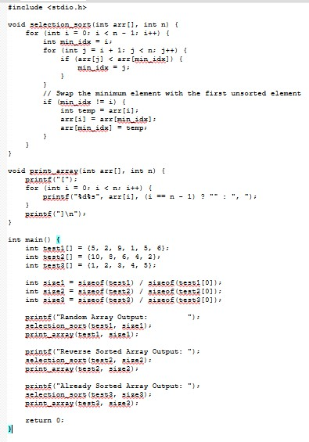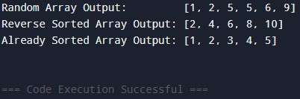
Time complexity: $O\left(N^{2}\right)$
Space complexity: $O\left(1\right)$

3.
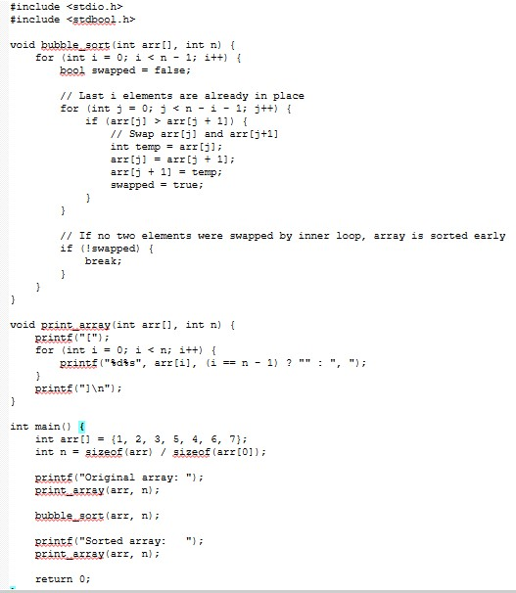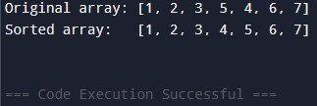
Time complexity: $O\left(N\right)$ best case (when already sorted) and $O\left(N^{2}\right)$ worst/average case;
Space Complexity: O(1)

4.
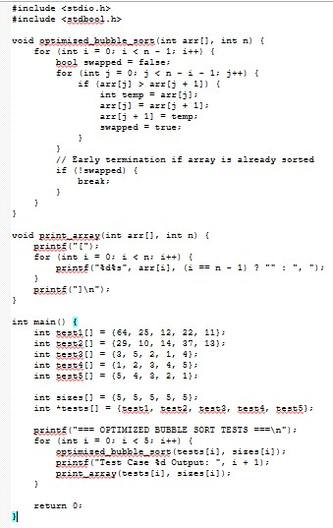
Output:
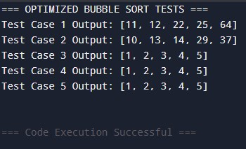
Time complexity: $O\left(N\right)$ best case (sorted/all identical) and $O\left(N^{2}\right)$ worst/average case
Space complexity: O(1)

5.
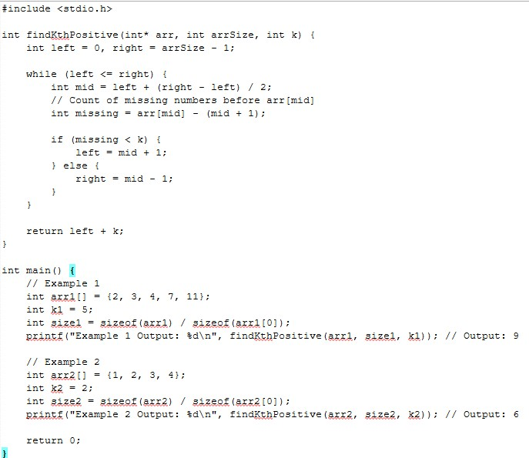
Output:
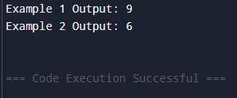

Time Complexity: $O\left(\log{N}\right)$
Space Complexity: O(1)

6
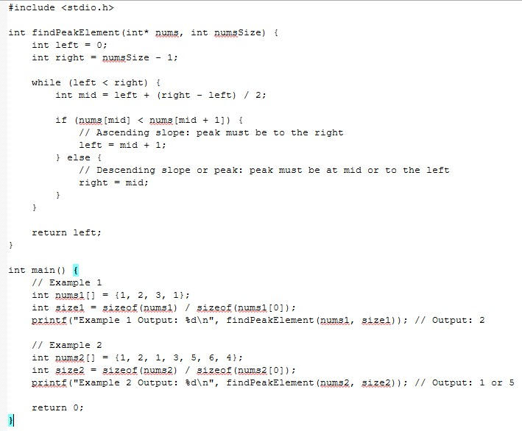
Output:
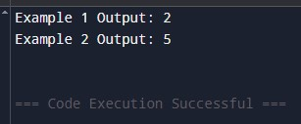
Time Complexity: $O\left(\log{n}\right)$
Space Complexity: $O\left(1\right)$

7.
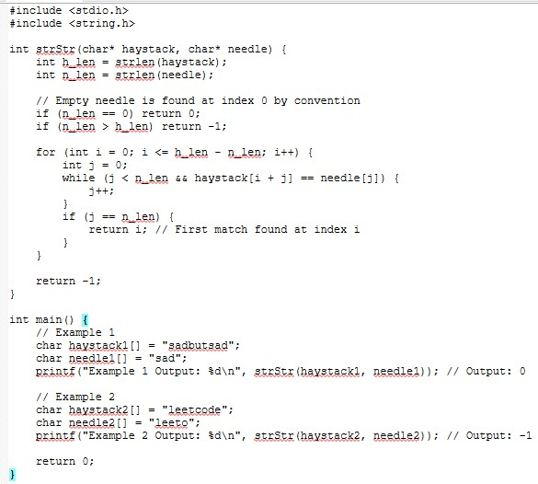
Output:
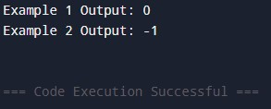
Time Complexity: $O\left(N×M\right)$
Space Complexity: $O\left(1\right)$

8.
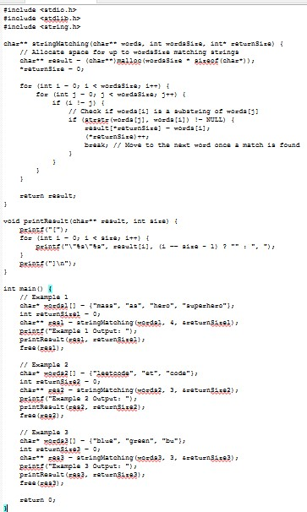
Output:
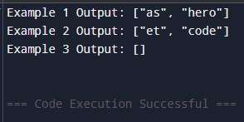
Time Complexity: $O\left(N^{2}×L^{2}\right)$
Space Complexity: $O\left(N\right)$

9.
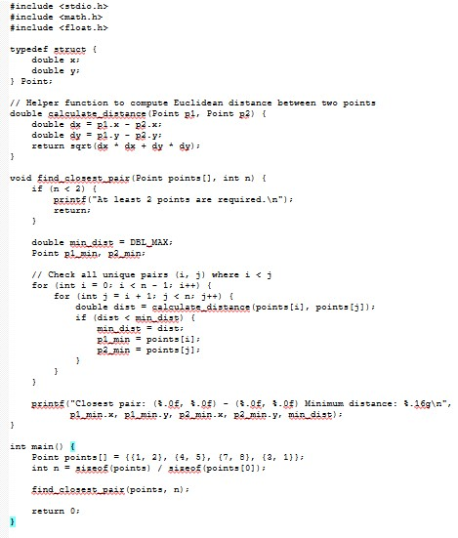
Output:
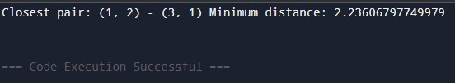
Time Complexity: $O\left(N^{2}\right)$
Space Complexity: $O\left(1\right)$

10.
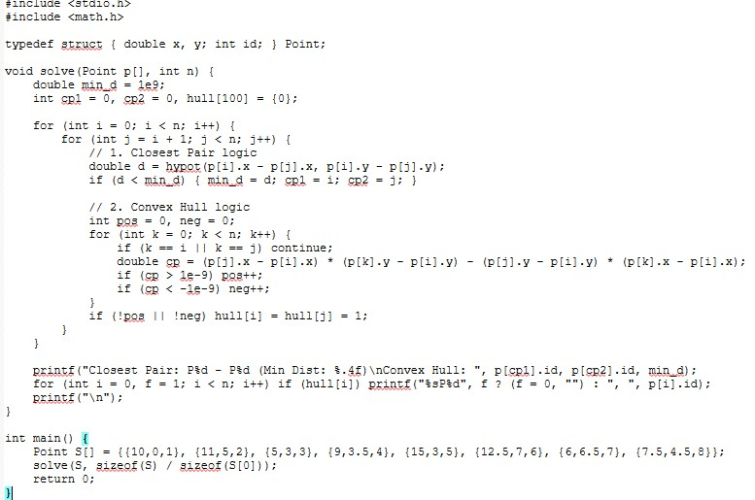
Output:
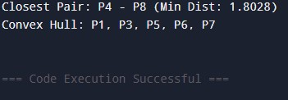
Time Complexity: $O\left(N^{2}\right)$ for Closest Pair and $O\left(N^{3}\right)$ for Brute Force Convex Hull
Space Complexity: $O\left(N\right)$

11.
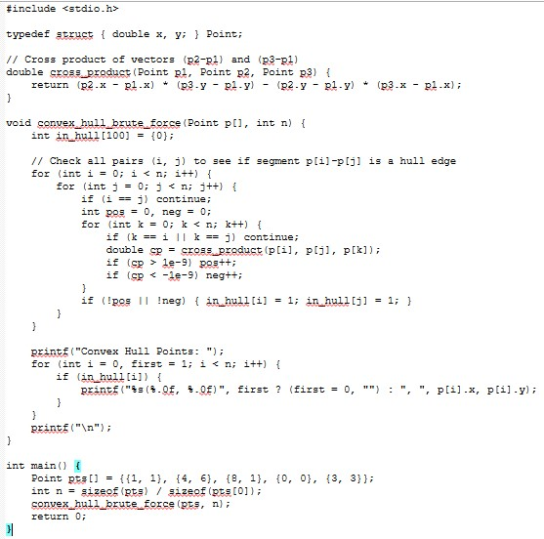
Output:
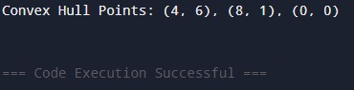
Time Complexity: $O\left(N^{3}\right)$
Space Complexity: $O\left(N\right)$

12.
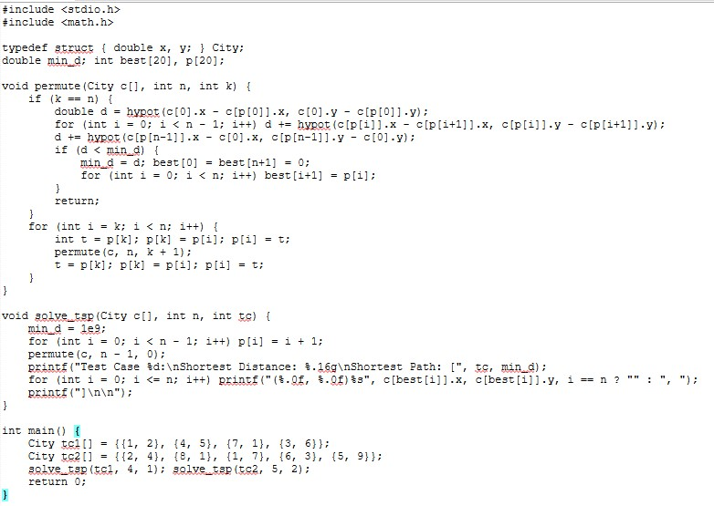
Output:
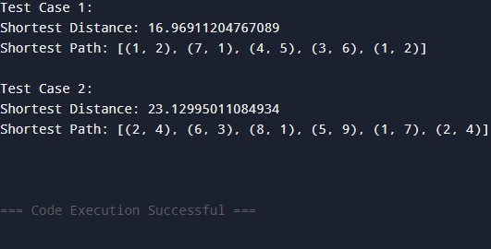
Time Complexity: $O\left(\left(N-1\right)!×N\right)$
Space Complexity: $O\left(N\right)$

13.
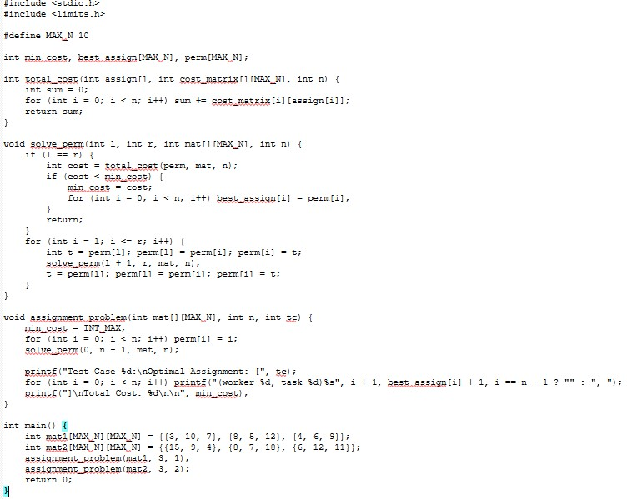
Output:
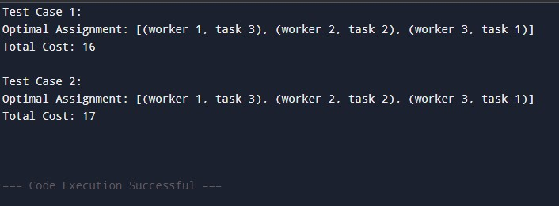
Time Complexity: $O\left(N!×N\right)$
Space Complexity: $O\left(N\right)$

14.
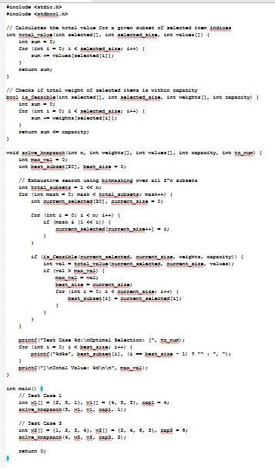
Output:
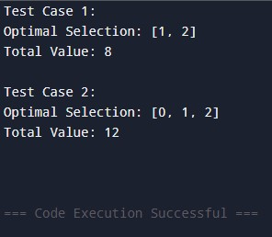
Time Complexity: $O\left(2^{N}×N\right)$
Space Complexity: $O\left(N\right)$

